Your Name is a Line

**Name Tag Designs**

White paper cut to 4”x 12

Pencil

Colored markers

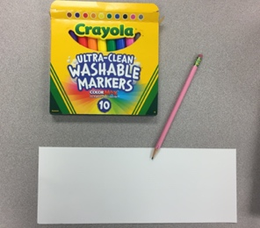

This is our welcome back to art lesson where we will make a piece of art using the letters of your name! Each letter is made with a line which is an Element of Art.

**Elements of Art are : line, shape, color, texture, space, value and form.**

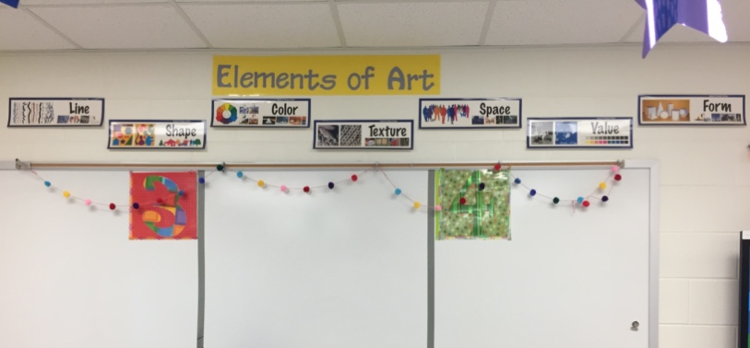

Each element is like a building block that artist use to create works of art. We will explore line, shape, and color in this lesson.

We will also use a few **Principles of Design** like pattern, rhythm, and movement.

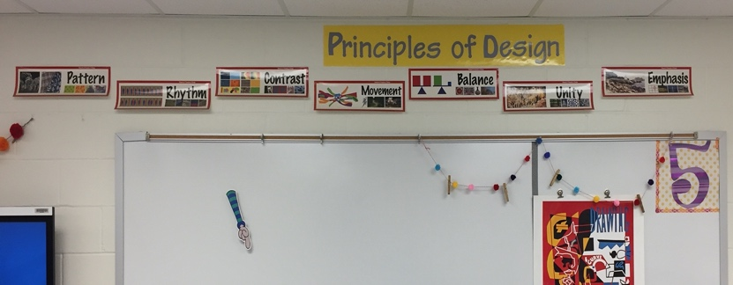

Principles of Design are another set of tools artists use to create works of art. The principles organize the elements allowing you to create many things. When you create art you naturally use these elements and principles and we will get use to calling them by name as we move through the year!

This week in art we will use the letters of your name to make a work of art. Two artists that I enjoy looking at are Stuart Davis and Wassily Kandinsky. These two artists make art using lines, shapes and colors.

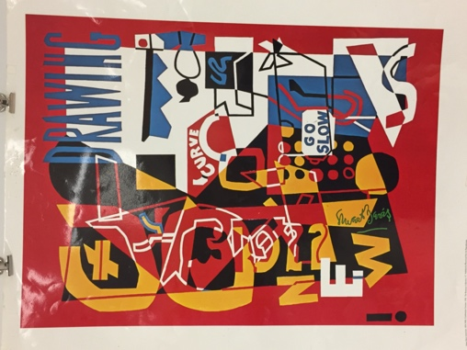 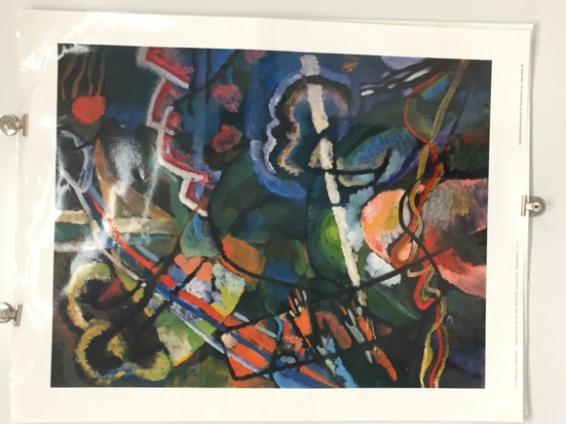

Combination Concrete by Stuart Davis Composition Storm by Wassily Kandinsky

We will talk about the two artists in class. Stuart Davis is an American painter and Wassily Kandinsky is a Russian painter.

What do you see when you look at these two paintings?

Stuart Davis was an Abstract artist and Wassily Kandinsky was the pioneer of Abstract art.

Take a regular sheet of white copy paper or white drawing paper and fold it in half vertically. Cut down the line center to make two pieces. You will need only ONE for this project.

LIGHTLY sketch the letters of you name on the white paper making the letters almost touch the top and bottom of your paper. Remember to sketch/draw light until you have it right ☺ 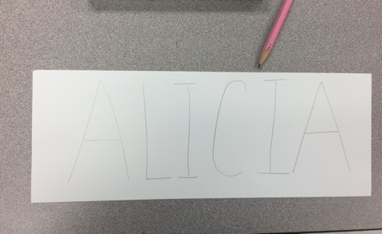

Trace OVER your pencil letters with Black marker making the letters VERY BOLD/THICK. 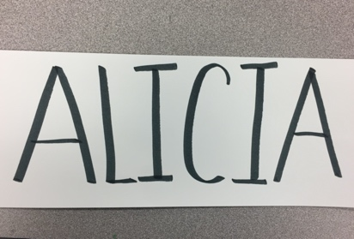

Keeping in mind the Elements of art: Line, Shape and Color and the Principle’s of Design: Pattern, Rhythm, and Movement as you make designs to fill the negative or empty spaces around your name.

Keep in mind we NEED to be able to read your name ☺ . Have fun, express yourself!

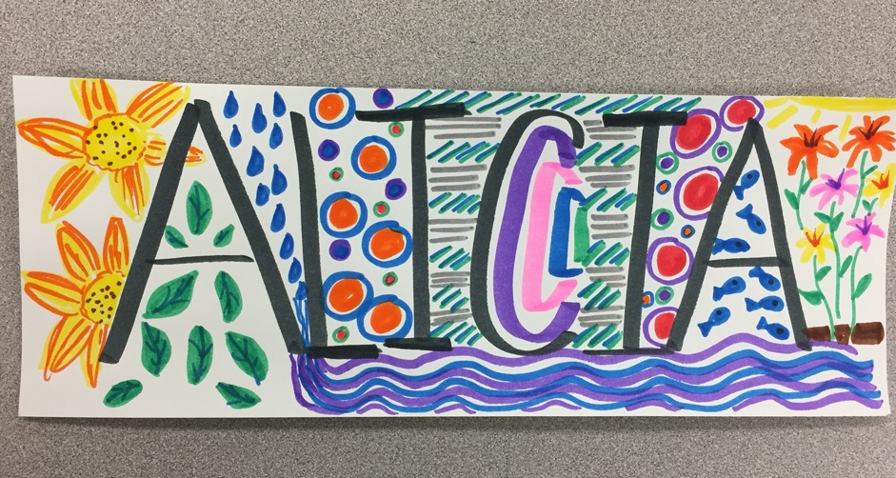

In the classroom we will tape these to the front of your desk so that everyone can read your name easily. At home artists, can hang them on a bulletin board in your room or on the refrigerator door!